**Question 1:**

**Find out the mail servers of the following domain :**

**Ibm.com**

Type the command nslookup

set type=mx

ibm.com

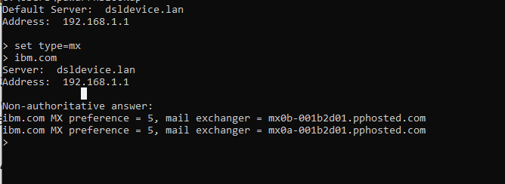

**Wipro.com**

Type the command nslookup

set type=mx

wipro.com

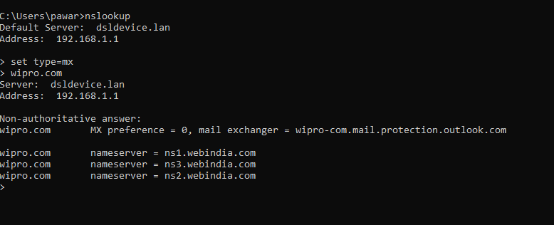

**Question 2:**

**Find the locations, where these email servers are hosted.**

Type the command nslookup

set type=mx

**Question 3:**

**Scan and find out port numbers open 203.163.246.23**

nmap 203.163.246.23

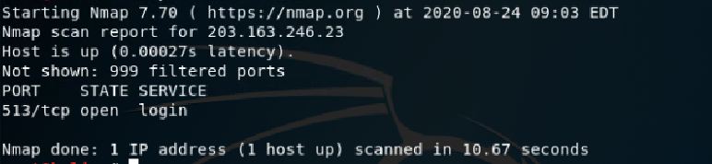

**Question 4:**

**Install nessus in a VM and scan your laptop/desktop for CVE.**

First, you have to create a scan. To create your scan:

1. In the menu, click Scans.
2. In My Scans page, click the New Scan button.
3. Choose scan template
4. Configure scan settings by selecting following:
   1. Name of scan
   2. Description of scan
   3. Folder for saving scan results
   4. Targets to be scanned
5. Configure other settings and credentials
6. **To view vulnerabilities:**
7. Click Scans.
8. Click the scan for which you want to view results.
9. Do one of the following:
   1. Click a specific host to view vulnerabilities found on that host.
   2. Click the Vulnerabilities tab to view all vulnerabilities.
10. Clicking on the vulnerability row will open the vulnerability details page, displaying plugin information and output for each instance on a host.